**Describe a couple more use cases**

*Post the facilitated Sport/Event*

|  |  |
| --- | --- |
| Name | Post the facilitated Sport/Event |
| Description | Students can post an event or view events |
| Actor | Student |
| Entry Condition | Login, Student access to the facilitated Sport/Event page |
| Exit Condition | Post an event, View the list of events |
| Flow of the event | 1. Students can click the “event ” button on the homepage after  they login to open the event page •  2. They can click the “post event” button to create an event •  3. They will need to fill in a form for this event about the  location ,time, content ,aiming group, and so on. •  4. At the bottom part of this page, student can choose to add this  event into a public calendar for future reminding |
| Exception | None |
| Special Requirement | None |

|  |  |
| --- | --- |
| Entity Object | - Event Information |
| Boundary Object | - View Button for the list of events  - Events List View page  - Post button to post an event |
| Control Object | - Post an event  - Show the list of events |

*Communication Message Board*

|  |  |
| --- | --- |
| Name | Communication Messages Board |
| Description | Students can communicate through leaving messages on Board |
| Actor | Student |
| Entry Condition | Login, User access message board page |
| Exit Condition | Message Board page |
| Flow of the event | 1. Students click “message board” button on the homepage after  they login to open the message board page. •  2. The messages left on this page will be organized by the order of time and the titles. •  3. Students can click the titles of message to review the detail. If they are interested in the message they can directly reply. •  4. Students can also choose to leave a message by click the button “leave a message” on the top of the page . •  5. They will go in to the page for creating a message, here body part for the message and provide their information on information part(optional) |
| Exception | None |
| Special Requirement | None |

|  |  |
| --- | --- |
| Entity Object | - Message Board |
| Boundary Object | - Message Board page |
| Control Object | - Message Board view |

**Identify and address design goals**

*Design goals*

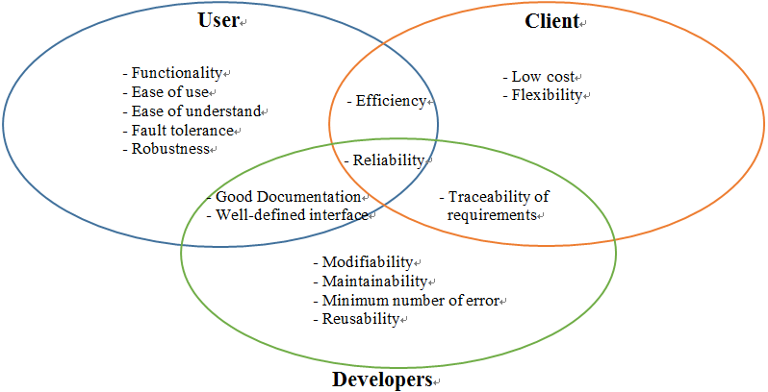

*Addressing the goals*

**- Functionality, Modifiability, Maintainability, Flexibility:**

We can achieve them through a good design of the system structure including

the layers and the classes, and the design patterns.

**- User-Friendliness, Ease of Use, Ease of Understand:**

We can achieve them through a good design on the webpage or give some hint onsome functions on the webpage (optional)

**- Robustness, Reliability, Efficiency, Low-cost:**

We can achieve them through optimizing on code and multi-test on the runtime on the code, we also need to set up criteria on the response time to avoid interrupting the user’s flow of thought

**- Fault Tolerance, Minimum Number of Error:**

We can optimize the phase of system testing.

**- Good Documentation, Traceability of Requirements:**

We can achieve them through the frequent update and backup on the rationale

decisions and documenting all the original requirements.

**Perform (essential) object modeling**

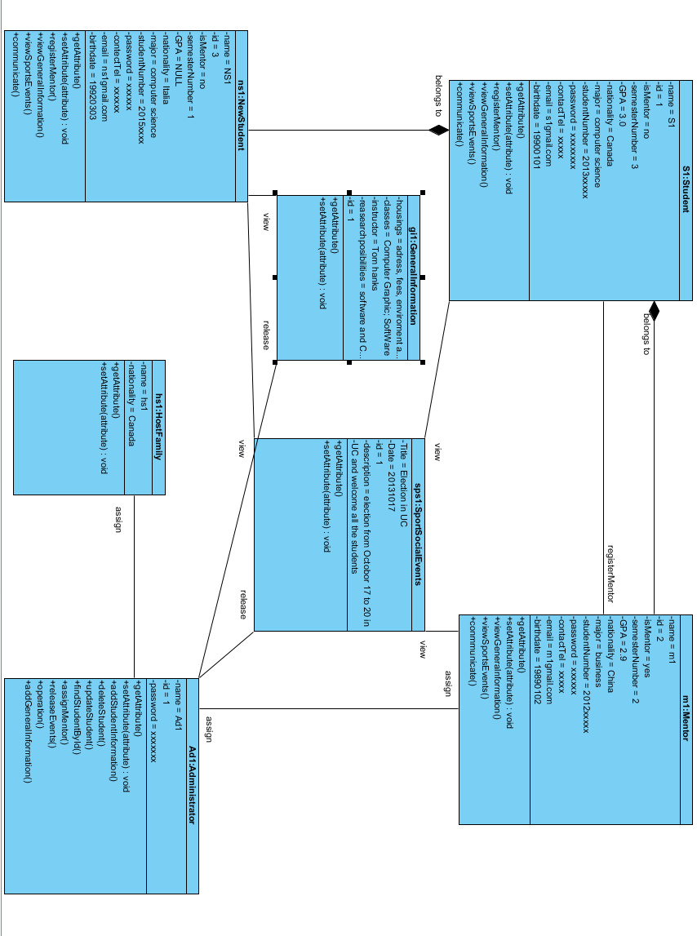

**Decompose the system**

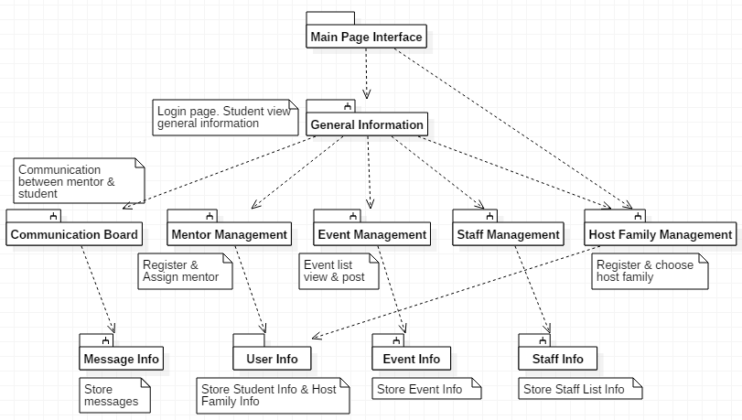

**Decide about the logical architecture (e.g. layering)**

*MVC Architectural Style*

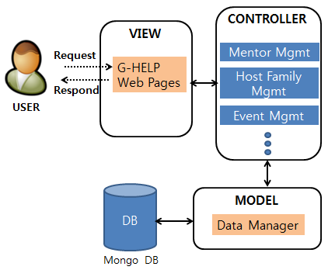

**Implement a first prototype.**

**LINK:** https://github.com/KwangsubAhn/G_Help